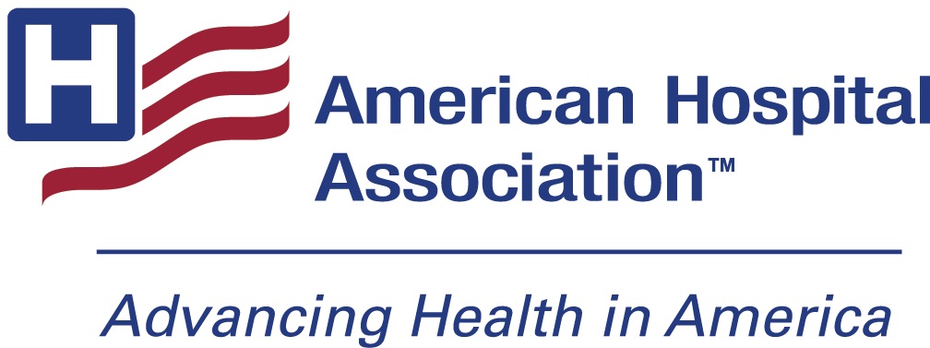

2027 Foster G. McGaw Prize Social Media Toolkit
Summary: The Foster G. McGaw Prize honors organizations that demonstrate a strategic approach to community health and well-being, improve access to care and address societal factors that influence health. One winner and three finalists will receive cash awards. For more information and to download an application, visit the Foster G. McGaw webpage (https://www.aha.org/fostermcgaw).
Weblink: Foster G. McGaw Prize | AHA
Sample Social Posts:
Registration Open post
- Applications are now open for the 2027 Foster G. McGaw Prize! The award honors organizations that improve health through community investments and co-designed initiatives and programs. Applications are due May 5. Learn more and start an application: (https://www.aha.org/fostermcgaw)

- Don’t miss the application deadline for the 2027 Foster G. McGaw prize! Apply by May 6 for an opportunity for your hospital or health system to be recognized for your work in advancing community health and well-being.

- The applications are now open for the 2027 Foster G. McGaw prize! Applications are due May 5 -- click here to read about past honorees and to download this year’s application. (https://www.aha.org/fostermcgaw)
- The applications are now open for the 2027 Foster G. McGaw prize! Applications are due May 5 -- click here to view a short video and to download this year’s application.
- The 2027 Foster G. McGaw prize will honor those hospitals and health systems that are addressing societal factors that influence health, increasing access to care and driving sustainable improvements. Learn more about the award, read stories from past honorees, and begin an application here: (https://www.aha.org/fostermcgaw)
Awards Given Out
- Thank you to all who applied for the 2026 Foster G. McGaw Prize! Your amazing work in communities is greatly inspiring, and we hope to see more exciting applications next year.

- [specifically for winner] Congratulations to ______ (winner name) for receiving the 2026 Foster G. McGaw prize for their outstanding work in improving health equity and community health in their area.
Hashtag:
#WeAreHealthcare

